***An Analysis of Unconventional Fossil Fuel Extraction Methods and their Impact on the Environment***

*Josh Worden (260663427)*

*04/16/2018*

*GEOG 300: Cultural Ecology*

*Professor George Wenzel*

**Abstract**

The discovery of fossil fuels in the form of coal, natural gas and oil have been immeasurably instrumental in the development of modern civilization as we know it today. These resources are considered by many to be the lifeblood of our current world economy. Fossil fuels played a significant role in the synthesis of many of the phenomenon that we are experiencing now like rising standards of living, technological innovation, increasingly interconnected global markets and more sophisticated forms of governance and society. With that said, we are also beginning to deal with some of the associated consequences of past decisions. This is a direct reference to climate change.

This paper will explore two recent unconventional fossil fuel extraction methods, specifically the mining of tar sands and fracking through a cost/benefit analysis of their role in the current phenomenon of human-induced climate change. In addition, an analysis through an critical lens will be applied to determine whether these controversial technologies contribute or mediate the human-induced phenomenon of climate change.

In the first section of this research paper, a description of how fossil fuels are formed, found and extracted will take place. This will provide the general background knowledge regarding the main processes associated with the fossil fuel industry, while also effectively creating the setting to introduce the newer, more controversial extraction methods of Hydraulic Fracturing and Tar Sand Mining. In the second section, a cost/benefit analysis of these two extraction methods will occur. This analysis will incorporate a plethora of different factors including economic, environmental, political and health. In the final section, here will be a discussion seeking to determine whether these two extraction methods in question contribute or mediate the effects of human-induced climate change. Furthermore, this section will also include an outline climate change and its associated predicted effects, with a specific focus on its impacts to our current world system. The final section will conclude with a final conclusion of the scope and implications examined in this research paper.

Key-words: fossil fuel extraction methods, fracking, tar sands, coal, natural gas, oil, cost/benefit analysis

**BODY**

**Ⅰ. Fossil Fuel Overview**

Fossil fuels, primarily in the form of coal and oil were the driving forces that catalyzed the Industrial Revolution. They catalyzed one of the most dynamic and innovative eras in our history. They also represent humanity’s most important source of energy to date (See Appendix 1). The three primary and most commonly used fossil fuel sources are coal, natural gas and petroleum. In this section, a brief overview of how each is formed, found and produced will take place.

**The formation of Fossil Fuels**

Coal is a combustible sedimentary rock composed primarily of carbon and hydrocarbons. It is black or dark-brown in color, and is the most ubiquitous fossil fuel source in many places, including the United States. There are different classifications of coal based on their carbon content, including lignite, Bituminous, and anthracite. Natural gas is a much cleaner energy source in terms of pollutants emitted relative to coal. It consists mostly of methane and hydrocarbon gas liquids. Moving on, petroleum or commonly referred to as crude oil, is a naturally occurring liquid that is composed of hydrocarbons and other organic compounds. It is stored in the same geological subsurface formations as natural gas.

Coal is formed in environments characterized by an absence of oxygen, usually occurring in marine deltas and wetlands. The oxygen-free setting has the effect of drastically slowing the decaying process of organic matter, usually in the form of vegetation and ancient/prehistoric organisms and is over time buried under more recent layers of soil. As this oxygen-free layer of sediment is continually buried under more and more layers of soil, it becomes subjected to increasing levels of heat and pressure. Essentially, coal was formed from this applied synergy of heat and compression, which is referred to as the process of carbonization.

With regards to the formation of natural gas and oil,they undergo a very similar geologic process to that of coal. Essentially, the forces of heat and compaction exerted themselves on the buried layer of anaerobic organic matter in the form of vegetation and prehistoric organisms to the extent that they metamorphosed it into either natural gas or oil. This energy source is stored in geologic formations known as reservoirs, which are sandwiched above and below by impermeable rock layers.

**Description of processes associated with the Exploration of Coal**

There are currently 1.1 trillion tons of reserves that can be accounted for worldwide and it is estimate that this will last 150 years, given current production levels (Where). Coal is found in enormous underground formations called “coal beds” that can stretch 1500 kilometers and be as thick as 30 meters. Coal beds must be discovered through exploratory activities. To begin, geologic maps of high probability areas were created. This was followed by geochemical and geophysical surveying, which usually involved taking sediment and soil samples. Afterwards, if supported by empirical evidence, exploratory drilling would take place. The final step in this process was to determine whether or not the coal bed was sufficiently bountiful to be considered economically significant, in which case extraction infrastructure was constructed (Where).

**Description of processes associated with the Exploration of Natural Gas and Petroleum**

The process of searching for natural gas and oil has come a long way since the advent of seismic surveying, data-modeling and data imaging technologies. Beforehand, geologists would have to physically search on the surface for physical evidence of these underground reservoirs of natural gas. Nowadays, geologists begin by applying their vast wealth of geologic formations knowledge to identify those structures that are most likely to contain reservoirs of natural gas. One such known formation is referred to as anticlinal slopes (Natgas, 2013). Once an area has been chosen based on informed predictions, further testing takes places, in order to obtain more detailed information about the size and volume of the potential reservoir. Seismic surveying involves sending energy in the form of seismic waves into the earth’s crust and studies the interactions it has with different underground geologic formations. This has the effect of creating a accurate map of the potential reservoir. The rise of two-dimensional and three-dimensional seismic data imaging has catalyzed the speed and accuracy with which underground formations and geologic features are mapped. They grant a clear representation of the crust’s composition in a specific area. (See Appendix 2) This is tremendously useful in allowing for the exploration of petroleum and natural gas, as an actual image could be used to estimate the probability of formations existing in a particular area, and the characteristics of that potential formation (Natgas, 2013).

Once a strong certainty of the existence of the natural gas or oil reservoir has been established, exploratory wells are drilled into the earth’s ground. This has the effect of enabling geologists to study the composition of underground rock formations in greater detail, while also looking for physical evidence of these energy sources stored in the reservoir. As drilling an exploratory well is an expensive, time consuming effort, they are only drilled in areas where other data has indicated a high probability of petroleum formations (Natgas, 2013). Logging is a vital process that complements and expedites the drilling process. Logging involves performing tests during the driller process that harness the analytical power of GIS software programs to monitor the drilling, and provides detailed data regarding the types of subsurface geologic formations and their respective compositions and characteristics.

**Overview of the Extractive Processes necessary to produce Coal**

Regarding well-known extraction methods, coal is obtained either through surface or underground mining. Surface mining generally takes place when the coal is less than 200 feet below the surface. In order to expose the coal, giant machines remove the topsoil and then proceed to excavate the coal. Afterwards, in places with strong environmental regulations, the topsoil is returned and the area is allowed time to revegetate. The coal is transported to a facility, where the coal is processed to separate undesirable materials from the coal. Over the years, a number of different surface mining techniques have been developed that include strip-mining, auger mining, open-pit mining and mountaintop removal (Coal Mining). Concerning underground mining, it tends to take place when the coal is buried hundreds or even thousands of feet below the surface. There a number of different respective methods for extracting coal buried so deeply, and involve the use of heavy equipment, mine shafts, “elevators” and conveyor systems to move the coal to the surface.

**Overview of the extractive processes necessary to produce Natural gas and Petroleum**

Natural gas and petroleum have historically been extracted primarily through drilling vertically into the earth’s crust to tap into the known subsurface reservoirs that contain these resources. Oil or natural gas rigs are constructed directly above the known reservoirs, then a hole is drilled using the rigs’ drill bit into the ground and stops when it has punctured the top impermeable layer of the reservoir. The drill hole is then lined with a large diameter impermeable concrete pipe, that acts to insulate the drill hole. This ensures that the petroleum or natural gas doesn’t seep or leak through the rig’s pipe, while also enhancing the pipe’s integrity (Freidenrich and Strickland). At this point, the rig is activated and the petroleum or natural gas is extracted out of the ground. The collected oil or natural gas is then feed through a series of filtering processes, in order to separate any remaining water or other particles from the fossil fuel itself. The filtered product is then stored in large sealed containers. A pipeline is also constructed to connect the petroleum or natural gas to the local or national energy grid system. Thus, the fossil fuel source stored in these containers are feed into the energy grid system via the pipeline.

**Ⅱ. Cost/benefit Analysis of Hydraulic Fracturing and the Mining of Tar Sands**

**Hydraulic Fracturing**

Ever since the Industrial Revolution, humanity’s need for energy was risen exponentially. According to Hubbert’s research backed by the majority of the scientific community, global oil production peaked in 1970. Now, we are looking to extract the remaining oil generally found in difficult-to-access locations. Due to the depletion of most conventional natural gas and oil sources in North America have been exhausted, there has been a recent significant increase in the use of hydraulic fracturing, otherwise referred to as fracking. It is estimated that in the United States alone, fracking has taken place over one million times.

So, what exactly is hydraulic fracturing? Put simply, it is the unconventional recovery of oil and natural gas found deep underground. To expand, horizontal wells are bored into carefully chosen and surveyed locations, whereby the “fracking solution” is injected at extremely high pressure into the ground through the horizontal wells. This solution consists of on average between 3 to 8 million tons of water, in addition to many thousands of tons of sand and an undisclosed mixture of chemicals and additives (Lallanilla, 2018). Injecting this solution into the ground at such high pressure has the effect of creating innumerable small cracks in the porous layer containing the oil and natural gas. The sand then is embedded into these cracks, preventing them from closing when the fracking liquid is pumped back out. This forces the natural gas and oil to seep into the horizontal well. Once all the gas is collected, the well are removed and the drill hole is sealed.

**Cost/Benefit Analysis of Hydraulic Fracturing**

There are a number of benefits associated with hydraulic fracturing. Hydraulic fracturing is very effective at assessing oil and natural gas in difficult to obtain places. This is vitally important for a world economy, whose lifeblood is oil. The vast majority of our transportation, infrastructure, energy and agricultural systems require vast amounts of oil and natural gas to function. Thus, fracking represents a continuation of the status quo, bringing in economic growth to nations. Furthermore, all the operations involved in with hydraulic fracturing require lots of personnel, which serves to generate more jobs in the economy. From a political standpoint, as the majority of the oil is found and produced in the Middle East, this has granted this region disproportionate geo-political global significance and bargaining power. This has been notoriously exploited by OPEC, as their member states have approximately 80% of the world’s oil reserves, in addition to roughly 55% of the natural gas reserves (Organization). Given its monopoly on fossil fuels, OPEC has sought to keep oil prices high, to maximize their profit margins. Given this dynamic, hydraulic fracturing has allowed a number of developed nations to create more independent national energy policies.

Fracking is considered by many to be an extremely controversial extraction method of fossil-fuels. In an age with increasing populations and associated increases in food, water and energy, water is becoming continually scarcer and more precious. This is exacerbated by the hugely-intensive water requirement associated with fracking. According to one study, the amount of water used on average for one well is equivalent to the drinking needs of 65,000 people (Wihbey, 2015). Another notable risk is the threat of permanently contaminating the groundwater. This has obvious and very serious health repercussions for the populations that use this groundwater for agricultural, as well as drinking reasons. Even with strong environmental regulations, there have been instances of the groundwater becoming contaminated in the United States. Another health consideration has to do with some of the chemicals used in the solutions. For instance, formic acid and benzene are both included in the fracking solution and can cause grave damage to one’s health when exposed to these chemicals. Lastly, there is a growing concern amongst the scientific and lay community that fracking is changing the geology of the land in a potentially negative way. More specifically, it is believed that there’s a positive correlation between earthquakes and fracking. The 2014 *Annual Reviews of Environment and Resources paper* states that “between 1947 and 2000, geologists observed a rate of 21 earthquakes of 3.0Mw or greater in the central United States per year” (Wihbey, 2015). This happens to coincide with the fact that the majority of fracking being conducted in the United States occurs in the Midwest and Rockies regions (See Appendix 3).

**Mining of Tar Sands**

Another recent unconventional fossil fuel extraction method that is seeing increased implementation and use is that of the mining of tar sands. These tar sands refer to the mixture of sand, clay and water that contain bitumen, a particularly heavy crude oil particle. The rising usage of this controversial method can be attributed to the growing scarcity of “easy oil”, which Michael Klare defines as, “oil that’s found on shore or near to shore; oil close to the surface and concentrated in large reservoirs” (Klare, 2007). Therefore, in order to maintain the status quo world system in place, the “hard” oil must be exploited and extracted.

Tar sands mining occurs either through open pit or in-situ mining. Open pit mining takes place when recovering bitumen buried within 75 meters below the earth, and involves a number of processes. First, large machines “shovel” tons of the tar sand mixture into equally large dump trucks that then transport their load into extraction plants. At this stage, the tar sand mixture is broken down and mixed with heated water, in order to separate the bitumen from the sand and clay (About Tar, 2012). Afterwards, the bitumen is further processed, so that it becomes synthetic conventional oil. With regards to in-situ mining, it represents roughly 80% of all tar sands mining and occurs at 80 meters below the surface. This method involves drilling horizontal wells into the area containing the bitumen, then liquefy the bitumen from the clay and sand mixture by pumping superheated steam through the wells. This has the effect of separating the bitumen from its clay and sand mixture. This liquefied bitumen then seeps into the wells and is pumped back to the surface through steam assisted gravity drainage (Oil Sands, 2018). This liquefied bitumen also requires further refining before it can be converted into conventional oil.

One of the world’s largest tar sand mining operation takes place in Northern Alberta, Canada. The Athabasca tar sands project was launched in the 1980’s and is considered by many to be very controversial. In 2008, it was producing 1.3 million barrels of oil on a daily basis (Lester, B 2009). To put this into perspective, their production represented roughly 7% of the U.S. current annual oil consumption.

**Cost/Benefit Analysis of Tar Sand Mining**

One can argue that hydraulic fracking and tar sands mining share many common benefits. They both require large number of workers to operate the sites. This represents an increase in the number of jobs in the economy, which has the effect of reducing unemployment while generating more disposable income that serves to grease the proverbial wheels of the economy. Another benefit arising from the mining of tar sands is that it reduces dependence on OPEC, which has serious political implications. Finally, the oil produced from this method prolongs the lifetime of our current global economic system, which heavily relies on oil to function. This grants us more time to prepare and deliver sustainable solutions to this rising crisis.

There a many limitations associated with the mining of tar sands. To start with, it is highly inefficient. For every barrel of crude oil produced, two tons of sand must be mined. In addition, for every gallon of oil produced, approximately 6 gallons of water are consumed in the extraction and refining stages (What are Tar). This can be prohibitively expensive, especially in the Western states and provinces of North America, where water is already a precious and scarce resource. Thirdly, extracting the bitumen form the sand mixture is highly carbon-intensive. It is estimated that the carbon emissions tied to the production of a single barrel of oil from tar sand mining is at least three times higher than that of conventionally producing a barrel of identical size. (Plan B 4.0) Thus, it is obvious that these method is very inefficient, as the input-to-output ratio is very poor. Furthermore, the waste products of tar sand mining are highly toxic, and represent a contamination threat to the nearby groundwater. This has obvious potential negative health implications. Finally, this technique is highly invasive, as it utterly degrades the natural environment, making it uninhabitable to the vast majority of fauna and flora. From an aesthetic perspectives, these sites have the appearance of toxic, desolate wastelands. (See Appendix 4)

**Ⅲ. Analysis of whether these two unconventional oil extraction methods contribute or mediate climate change**

With regards to hydraulic fracking and the mining of tar sands, this section of the paper will analyze whether these unconventional fossil-fuel extraction methods contribute to or mediate the effects associated with human-induced climate change.

Hydraulic fracking inherently contributes to climate change, as it produces oil. It is well known that when oil is burned, it emits greenhouse gases into the atmosphere, namely in the form of carbon dioxide. Furthermore, as fracking is very water-intensive, this further contributes to the worsening of the associated effects of climate change. To add on, this also has serious social implications, especially considering that we live in an age where freshwater is becoming scarcer. This will accelerate and worsen the potential risk of extreme competition between groups for the basic necessities of life. Moreover, fracking involves the very serious risk of contaminating local water sources, as well as soil types. This may have long-term negative implications for the ability of the local area to provide the conditions necessary for life. Specific to climate change, this would compromise the affected area’s ability to naturally counteract climate change, in the form of having trees and vegetation that act as carbon sinks. All in all, there isn’t a single aspect of fracking that actively mediates climate change.

Tar Sand mining is no different, in the sense that at its end-goal is the production of natural gas and petroleum for human consumption. These contributes to the worsening effects of climate change by simply producing the resources that when burned, emit greenhouse gases and other contaminants. Moreover, the mining of Tar Sands is highly inefficient, with regards to the input-to-output ratios. The sheer amount of water that is required in the process of refining the bitumen is astronomical, and has very serious long-term implications. In addition, the process of extracting and refining bitumen into crude oil involves enormous energetic inputs, translating to high carbon costs. The related greenhouse gas emissions of mining and refining the tar sands is approximately 79 kgs per barrel, while heating the bitumen to fully separate it from its constituents boosts these greenhouse gas emissions to roughly 120 kgs per barrel or oil (Special Report 2014). Alberta’s tar sands act aa a significant contributor to the propagation of climate change, as it’s estimated that 170 billion barrels of oil will be extracted from the tar sands. Scientists have predicted that the fossil fuel industries in Alberta alone, of which the Athabasca Tar Sands operation is a major player will result in a 0.4 Co increase in temperature. Lastly, the invasive nature associated with the extraction of oil and natural gas from the tar sands degrades the local environment, to the point where it becomes inhospitable for life. As mentioned above, this nullifies the area’s capacity to cultivate life, most in the form of plants and vegetation, which would help to mitigate climate change.

**Associated and predicted effects of Climate Change**

Climate change is a relatively recent phenomenon whereby human activity is effectively changing our natural earth systems. This is attributed to the emissions of greenhouse gases, such as carbon dioxide and methane. It is estimated that in 2008, some 8 billion tons of carbon were emitted from the burning of fossil fuels and 1.5 billion tons were emitted from deforestation (Lester, B 2009). This will have the effect of changing the spatial distribution of weather patterns around the globe for an extended length of time. The Intergovernmental Panel on Climate Change has projected that average global temperature will increase between 1.6-6.4 degrees Celsius. This will have devastating implications for human civilization. Higher temperatures will greatly diminish agricultural crop yields, accelerate the melting of mountain glaciers that feed many of the world’s largest and most vital rivers, increase the severity and frequency of destructive storms, and intensify droughts (Lester, B 2009). Furthermore, higher temperatures will accelerate the melting of the polar ice sheets, which in turn will increase the average sea level, leading to many low-lying areas becoming submerged. Many of the world’s largest cities will be submerged, like Miami, London, Singapore, Bangkok, New York; not to mention the incredibly agriculturally productive asian river deltas.

The effects of climate change are estimated to displace millions or perhaps even billions of people from their homes, creating mounting pressure on countries and their governments. With a growing global population seeking to improve their standards of living and material wealth, a drastic reduction in agricultural yields may be ruinous. Many experts consider climate change to be a issue of national security, as dwindling natural resources will caused increased competition between groups of people for these resources. Moreover, many of the effects of climate change will experience positive feedback loops. This has very serious negative implications, as unless we completely put a stop to the emission of greenhouse gases, the natural environment will continue to make itself more inhospitable for conventional human life. For example, when insolation strikes the Arctic Ocean, approximately 70% of it is reflected back into space, and the remainder is absorbed. However, as the Arctic sea ice melts, the incoming sunlight will hit the much darker open water, which will have the effect of only reflecting back 8%, while the remaining 92% will be absorbed (Lester, B 2009) . This albedo effect explains why the shrinking of the Arctic sea is continually accelerating and contributing to rising regional temperature. In summary, if the current status quo continues, many of the effects of climate change will rosen and lead to the tipping point of the global environment to a new equilibrium, which is not likely to be as friendly to life as our current natural equilibrium.

**Ⅳ. Conclusion**

As former U.S. President Obama once said, “There’s one issue that will define the contours of this century more dramatically than any other, and that is the threat of a changing climate.” The current consumption and production patterns of fossil fuels, coupled with the growing scarcity of these resources and the rise of unconventional extractive methods with high carbon and other greenhouse gas emissions, is leading to a tipping point, whereby ecological, environmental and geologic forces will experiencing increasingly powerful positive feedback loops, propagating the shift away from our current natural equilibrium that is hospitable to life to a new equilibrium, that may not be so accommodating. Unless a global commitment to this issue is undertaken, accompanied by very large increases in investment in renewable energy sources, more efficient technologies, increased social awareness and much stricter environmental regulations occur now, many areas of the Earth will become unlivable, as the necessary resources for life will become very scarce. Ultimately, this will end in fierce and intense competition between populations for access to those resources. This is why this is a issue of national and global security.

**References**

About Tar Sands. (2012) *Oil Shale and Tar Sands Programmatic EIS.* Retrieved from <http://ostseis.anl.gov/guide/tarsands/>

Brown, L.R. (2009) PLAN B 4.0 Mobilizing to Save Civilization. New York, NY: w.w. Norton & Company, inc.

Coal Mining Technologies. (n.a.) *Tribal Energy and Environmental Information.* Retrieved from <https://teeic.indianaffairs.gov/er/coal/restech/tech/>

Freudenrich, C. and Strickland, J. (n.a.) Testing for Oil. *How Stuff Works.* Retrieved from <https://science.howstuffworks.com/environmental/energy/oil-drilling6.htm>

Klare, M. T. (August 16, 2007) Entering the Tough Oil Era. *TomDispatch.com.*

Lallanilla, M. (February 9, 2018) Facts About Fracking. *Live Science.* Retrieved from <https://www.livescience.com/34464-what-is-fracking.html>

Morse, E., Turgeon, A. (Dec. 22, 2012). Coal. *National Geographic Society.* Retrieved from [**https://www.nationalgeographic.org/encyclopedia/coal/**](https://www.nationalgeographic.org/encyclopedia/coal/)

Natgas. (September 20, 2013) Exploration. *Naturalgas.org.* Retrieved from <http://naturalgas.org/naturalgas/exploration/>

Organization of Petroleum Exporting Companies- OPEC. (n.a.) *Investopedia.* Retrieved from <https://www.investopedia.com/terms/o/opec.asp>

Oil Sands. (2018) *Canadian Association of Petroleum Producers.* Retrieved from <https://www.capp.ca/canadian-oil-and-natural-gas/oil-sands>

Special Report: Comparing GHG Intensity of the Oil Sands and the Average US Crude Oil. (May, 2014) *IHS Energy.* pp. 4. PDF format.

What are Tar Sands? (n.a.) Union of Concerned Scientists. Retrieved from <https://www.ucsusa.org/clean-vehicles/all-about-oil/what-are-tar-sands#.WtUTnRPwZE5>

Where is Coal Found. *World Coal Association.* Retrieved from [**https://www.worldcoal.org/coal/where-coal-found**](https://www.worldcoal.org/coal/where-coal-found)

Wihbey, J. (May 27, 2015) Pros and Cons of Fracking: 5 key issues. *Yale Climate Connections.* Retrieved from <https://www.yaleclimateconnections.org/2015/05/pros-and-cons-of-fracking-5-key-issues/>

**Appendices**

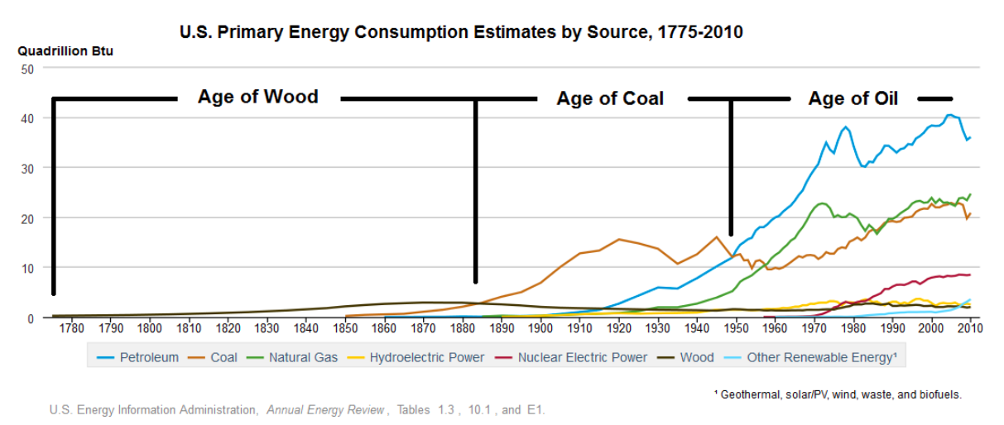

**Appendix 1: A chart illustrating the United States’ primary energy consumption patterns from 1775-2010**

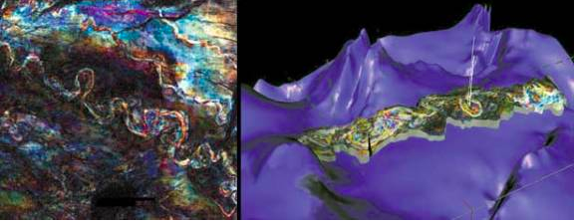

**Appendix 2: Three-dimensional Seismic imaging**

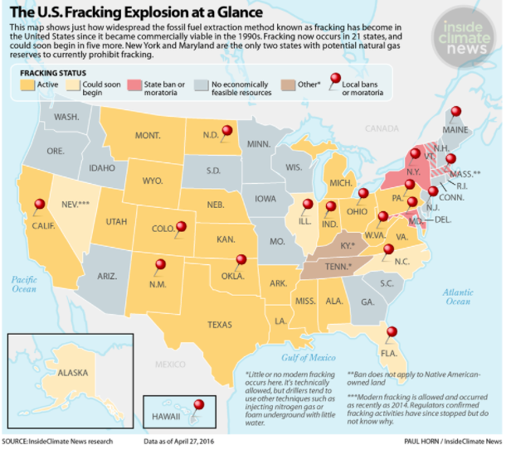

**Appendix 3: Geographic representation of Fracking Activities in the United States**

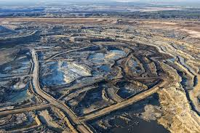

**Appendix 4: Image of the Athabasca Tar Sands**